Samuel Ross Johnson – Pedigree

“Ross” was born and lived in Hull all of his life except for a brief period of Armed Service in WW2. His family roots were in the fishing town of Filey, Yorkshire.

Contents:

Introduction
Biographies
- Samuel Ross Johnson 1920-1968
- George Samuel Johnson 1879-1951
- Jane Skelton 1881–1950
- Samuel Ross Johnson 1846–1893
- Betty Warcup 1842-1926
- Thomas Skelton 1860-1920
- Mary Crimlis 1861-1927
Data Evaluation
Appendices

1) Samuel Ross Johnson (“Ross”), Hull, 1909–1968.
Ross was born in Hull on 13th January 1909 as the second child and only son of George Samuel and Jane Johnson and he was eventually to have 6 sisters. He was a 2 year old male in the 1911 census with the family living in the Myton district of Hull.
Ross met his future wife, Gladys Rowe, in 1935 at the wedding of his friend Eric Pinder to Norah Rowe, and he married Gladys on 7th September 1940.
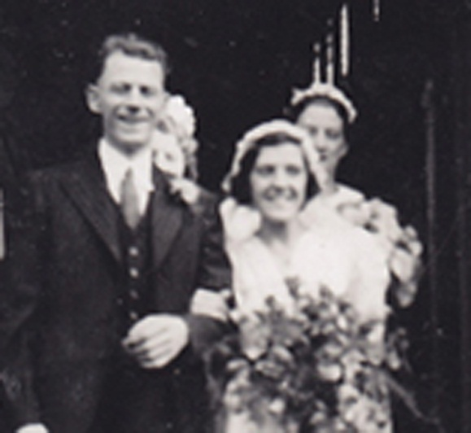
Image: Wedding day of Samuel Ross Johnson and Gladys Muriel Rowe;
Source: Johnson Family; Photographer: Unknown
Ross joined the Royal Pioneer Corps in May 1941 and his only child, Christine, was born in 1944.
Ross died on 30th August 1968 from a brain tumour, his occupation at that point being a general labourer in the tannery.

2) George Samuel Johnson, Filey, 1880–1951.
George was the eighth and last child of Samuel Ross Johnson, and Betty Warcup, and was born in the January-March quarter of 1880.

In 1881 George was aged one with Fanny 9, and Thomas 7, the two siblings to survive into adult life.
George, a Railway Porter, married Jane Skelton at St Stephens Church, Spring Bank, Hull on 28th April 1902.
George died in Hull in the July-September quarter of 1951.

3) Jane Skelton, Filey, 1881–1950.
Jane Crimlis was the first child of Mary Crimlis, and Thomas Skelton. Jane was born two weeks before the 1881 census and was with her (unmarried) mother in Murray Street, Filey, with the name Jane Crimlis. In 1891 Jane had the surname Skelton.
At her marriage to George Johnson in 1902 her father was a painter by profession.
Jane died in Hull in 1950.

4) Samuel Ross Johnson, Filey, 1846–1893.
Samuel Ross was the third child of four, and second son, of Samuel Ross Johnson (1816), and Frances Watkinson.
The birth of Samuel Ross in 1846 is deduced from his baptism 9th August 1846, and from his age (47 years) at death. In the 1851 census he was a 4 year old male living with parents in Filey.
In the October–December (possibly 29th November), 1865, he married Betty Warcup. They had eight children, three surviving into adult life.

In the 1881 census Samuel Ross was enumerated as “Ray” and Betty as “Bess”, and living in Chapel Street, Filey. Ray died in Filey in 1893 aged 47.
5) Betty Warcup, Flamborough, 1842–1926.
Betty (or Betsy) was the third child and second daughter of Thomas Warcup and Ann Cooling. She was born in Flamborough, in July or August 1842, and was baptised at St Oswald’s Church, Flamborough, on 28th August 1842.
In the October-December (possibly 29th November), 1865 Betty married Samuel Ross Johnson. They had eight children and Betty died in 1926.
6) Thomas Skelton, Snainton, 1860–1920.
Thomas Skelton was the third child and second son of Robinson Skelton and Mary Thompson, and he was born in October–December 1860 in Snainton in the registration district of Scarborough.
Thomas’s first child, Jane, was born in Filey two weeks before the 1881 census. In that census Thomas (a painter33), aged 20, was living in Church Street Filey, with his mother Mary, and two elder siblings.
In the final quarter of 1881 Thomas married Mary Crimlis, and they went on to have at least eight further children before Thomas died in Scarborough R.D. (probably Filey) in 1920.
7) Mary Crimlis, Filey, 1861–1927
Mary Crimlis was the fourth child and fourth daughter of John and Elizabeth Crimlis. The registration of her birth has not yet been traced, but her baptism was on 20th October 1861 in Filey.

In the 1871 Census Mary was a 10 year old Scholar, and in the 1881 census she was lodging in Murray Street, Filey, together with her 2 week old baby, Jane Crimlis. Mary (aged 20) was unmarried.
In the October – December quarter 1881 Mary married Thomas Skelton. She had at least eight further children, her last child, John Crimlisk Skelton, was born in 1907.
Mary died in Filey in 1927, aged 64.

Data Evaluation
On a scale of confidence from 1 low to 5 high, the evaluation is:
- Samuel Ross Johnson (1910): 5
- George Samuel Johnson: 4
- Jane Skelton: 4
- Samuel Ross Johnson (1846): 3
- Betty Warcup: 4
- Thomas Skelton: 4
- Mary Crimlis: 3

APPENDICES:
1) Pedigree Chart
2) Data Evaluation
3) Certificates
4) Bibliography

Appendix 1 – Pedigree Chart
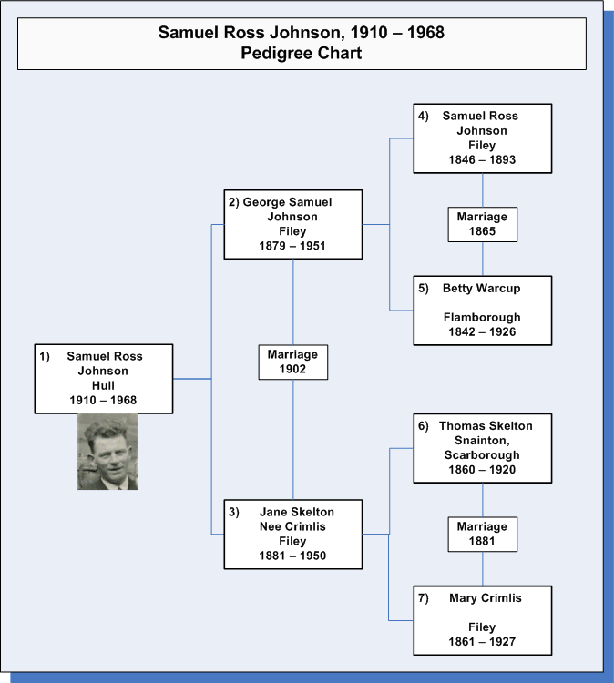

Appendix 2 – Data Evaluation
Documents and sources are scored on a scale of 1 – very poor through to 10 – excellent, and this score is aggregated on a scale of 1 through 5 for the overall quality of the data relating to the individual.
 |  |  | Primary document | Secondary document copy | Index to secondary document | Corroborations | Score | %age. | Quality  Scale 1-5
SR  Johnson | 1909 | Birth |  | On file |  | 1911 Census | 9
 | 1940 | Marriage | On file |  |  |  | 10
 | 1968 | Death |  | On file |  | Verbal | 9 | 93 | 5
GS  Johnson | 1880 | Birth |  |  | GRO v9d/p345 | 1881 Census | 9
 | 1902 | Marriage | On file |  |  |  | 10
 | 1951 | Death |  |  | GRO v2a/p164 |  | 6 | 83 | 4
Jane  Skelton | 1881 | Birth |  |  | GRO V9d/p355 | 1881 census | 9
 |  |  |  |  |  | 1891 census
 | 1902 | Marriage | On file |  |  |  | 10
 | 1950 | Death |  |  | GRO v2a/p194 |  | 6 | 83 | 4
SR  Johnson | 1846 | Birth |  |  |  | Baptism | 5
 |  |  |  |  |  | Census
 |  |  |  |  |  | Death
 | 1865 | Marriage |  |  | GRO V9d, p682 | Family search | 7
 | 1893 | Death |  |  | GRO V9d, p294 |  | 6 | 60 | 3
B Warcup | 1842 | Birth |  |  | GRO VXXXIII, p26 | Website, baptism | 9
 | 1865 | Marriage |  |  | GRO V9d, p682 | Family search | 7
 | 1926 | Death |  |  | GRO V9d, p425 |  | 6 | 73 | 4
T Skelton | 1860 | Birth |  |  | GRO V9d, p292 | 1881 Census | 9
 | 1881 | Marriage |  |  | GRO V9d, p677 |  | 6
 | 1920 | Death |  |  | GRO V9d, p505 |  | 6 | 70 | 4
M Crimlis | 1861 | Birth |  |  |  | Baptism | 6
 |  |  |  |  |  | 1871 census
 |  |  |  |  |  | 1881 census
 | 1881 | Marriage |  |  | GRO V9d, p677 |  | 6
 | 1927 | Death |  |  | GRO V9d, p404 | Birth of last child | 6 | 60 | 3

Appendix 3 – Certificates
Samuel Ross Johnson: Birth Certificate
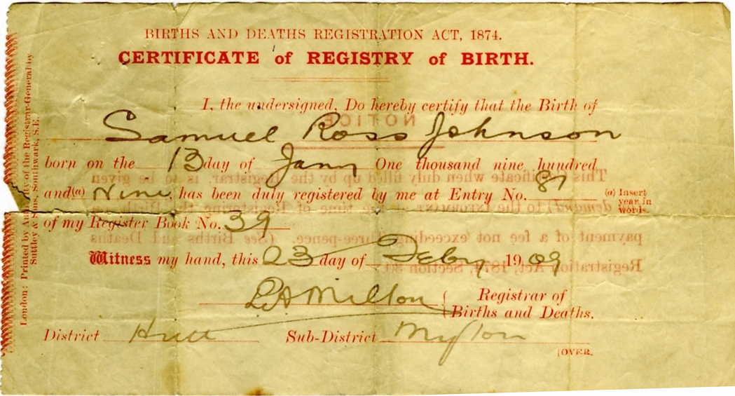
Samuel Ross Johnson, Marriage Certificate
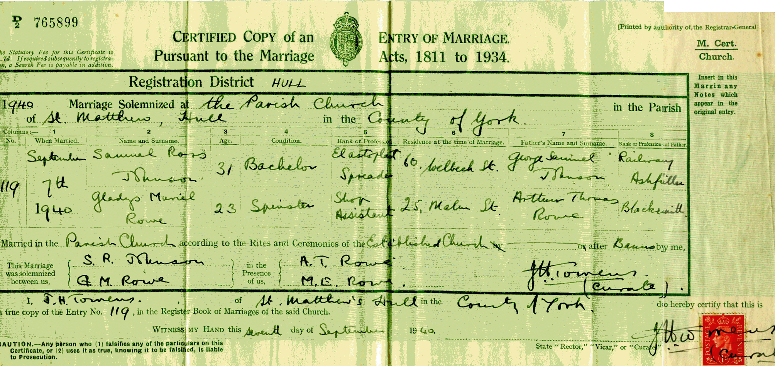

Samuel Ross Johnson: Death Certificate:
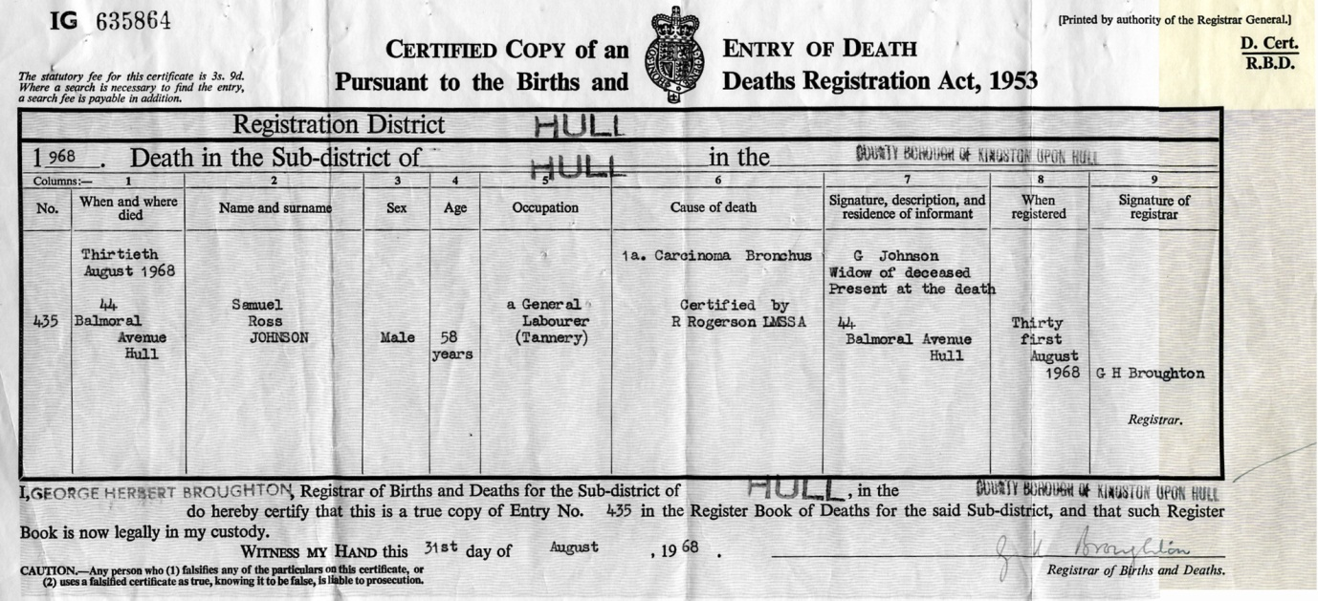
George Samuel Johnson / Jane Skelton Marriage Certificate
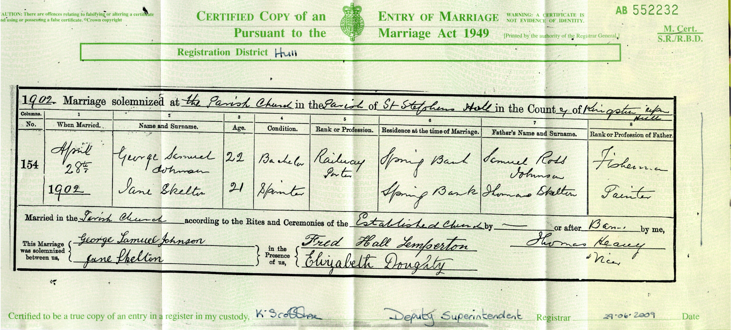

Appendix 4 – Bibliography
Websites
- FreeBMD :www.freebmd.org.uk, Birth, Marriage, Death data indices to GRO.
- FamilySearch: www.familysearch.org: Baptism Data, Census Data
- Church Family History: www.pchurch.org.uk/church/index.html Biographical details
- Flamborough Fishing Families: http://www.cimidd.karoo.net/
- FreeCen: www.freecen.org.uk Census Data
- The National Archives http://www.nationalarchives.gov.uk Census definitions
- Geograph: www.geograph.org.uk

SR Johnson - Birth Certificate – Appendix 3
Church Family History: http://www.pchurch.org.uk/church/family/f026.htm
FamilySearch: 1911 Census Extracthttp://tinyurl.com/6ea4vzs
Church Family History: http://tinyurl.com/6a9tpbl
Johnson – Rowe Marriage Certificate – Appendix 3
Unsubstantiated statements made by Gladys M Johnson.
Samuel Ross Johnson - Death Certificate – Appendix 3
Church Family History: http://www.pchurch.org.uk/church/family/f080.htm
GRO Volume 9d, Page 345
PRO RG11, Piece 4801, Folio 17, Page 28
Church Family History: http://www.pchurch.org.uk/church/family/f080.htm
Johnson Skelton Marriage Certificate Appendix 3
GRO Volume 2a, Page 164
GRO Volume 9d Page 355
PRO RG11, Piece 4801, Folio 46, Page 32
PRO RG11, Piece 3962, Folio 5, Page 4
Johnson Skelton Marriage Certificate – Appendix 3
GRO Volume 2a Page 194
Church Family History: http://www.pchurch.org.uk/church/family/f082.htm
FamilySearch, Batch No. C00770-2.
PRO H0107, Piece 2368, Folio 167, Page 22, GSU Roll 87646-87649
GRO Volume 9d, Page 682
FamilySearch Batch Number I02617-2
Church Family History: http://www.pchurch.org.uk/church/family/f080.htm
PRO Ref RG11, Piece 4801, Folio 17 Page 28
GRO Volume 9d, Page 294
GRO Volume XXXIII Page 26
Flamborough Fishing Families: http://www.cimidd.karoo.net/pafg49.htm#1764C
FamilySearch: England Births and Christenings 1538 - 1975, C10593-1
GRO Volume 9d, Page 682
FamilySearch, Batch No. I02617-2
GRO Volume 9d, Page 425
Church Family History: http://www.pchurch.org.uk/church/family/f162.htm
GRO Volume 9d, Page 292
1881 UK census: PRO RG11, Piece 4801, Folio 433, Page 5
GRO Volume 9d, Page 677
Church Family History: http://www.pchurch.org.uk/church/family/f128.htm
GRO Volume 9d, Page 505
Crimlisk One Name Study: http://www.pchurch.org.uk/crimlisk/families/f006.htm
FamilySearch: England Births and Christenings 1538 - 1975, C00770-2
PRO 1871 Census, Ref RG11, Piece 4801, Folio 20, Page 34
PRO 1881 Census, Ref Rg11, Piece 4801, Folio 46, Page 32
GRO Volume 9d, Page 677
GRO Volume 9d, Page 352
GRO Volume 9d, Page 404
Appendix 2

